Chapter 16, Problem 12.

Determine i(t) in the circuit of Fig. 16.35 by means of the Laplace transform.

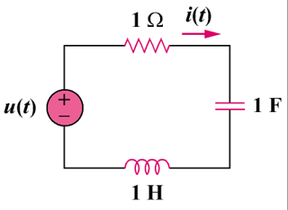
u(t)V

Figure 16.35
For Prob. 16.12.

